Problem Name: ROTTEN AUDIO

Author: Jayesh Bhave

Flag: vishwaCTF{M0RS3_M4K35_4UD10_R0T}

Problem:

Today Morning I got an Email Containing Audio File, but I am unable to Understand that audio, I think Audio got rotten.

Can you find what it means?

P.S.: Use Underscore ( _ ) instead of space.

Attachment: Audio file - audio.wav

Solution:

Step 1: Audio given here is Morse Coded Audio, hence decoding this Audio File from any Morse Audio Decoder will give a string.

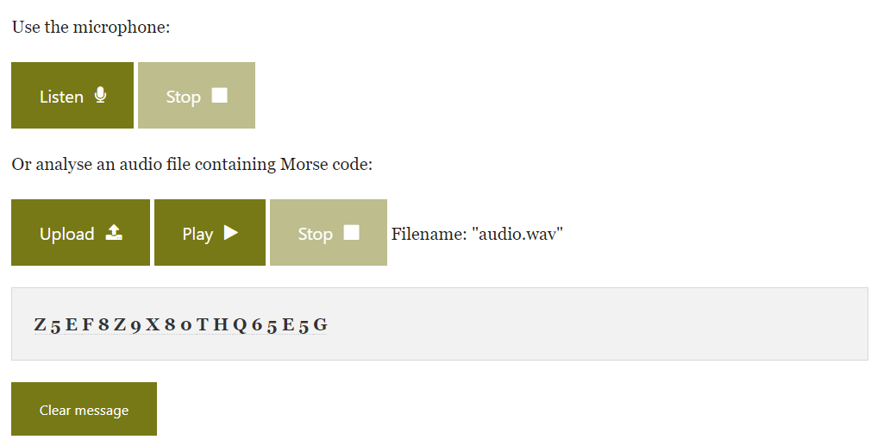

Step 2: This String seems like Ciphertext, which is encrypted using ROT-18. Hint for this encryption method is given the name of problem itself, i.e., "ROTTEN".

Step 3: Decrypting this Ciphertext using ROT-18 Decoder we can get final Flag.

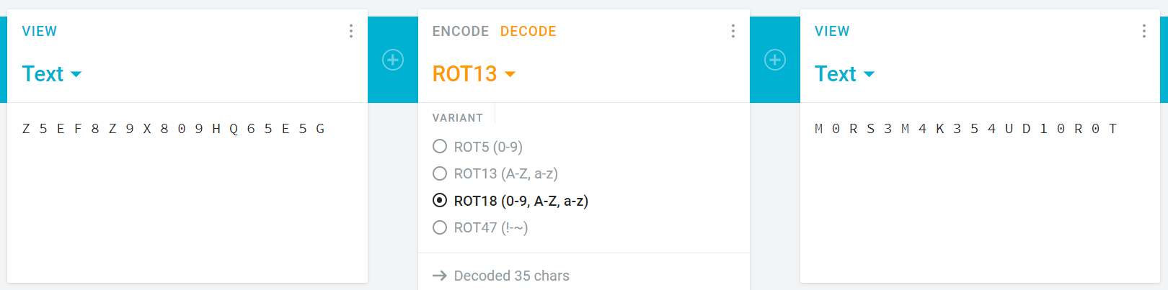

We must give Space after every word but using underscore instead of Space.

So, Flag will be decrypted which is M0RS3_M4K35_4UD10_R0T

Wrapping it with flag format Final Flag will be

vishwaCTF{M0RS3_M4K35_4UD10_R0T}